J. Disability Stud. 2023, 9(1), 39-40 . Book Review.
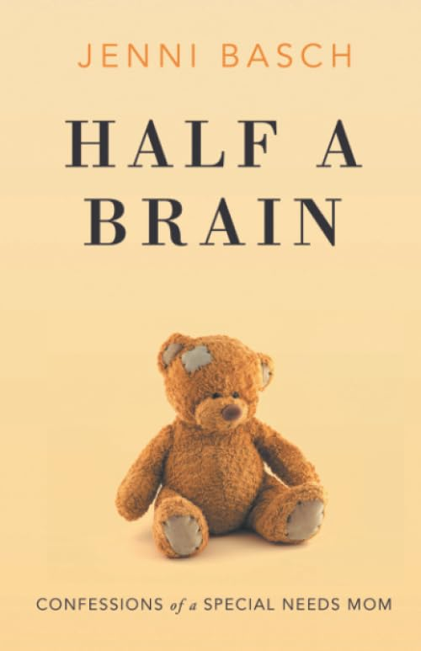
Journal of Disability Studies
Half A Brain: Confessions of a Special Needs Mom
Jenni Basch (Author)
Mile 18 Press, New Jersey
2020, English, Kindle Edition ASIN: ‎ B087NWXYR3 Pages 231, $3.99
Aneesh Joseph
Research Scholar, IGNOU, MCBS Emmaus Provincial House, Kaduvakulam, Kottayam-686004

Received on: 08-11-2023 Accepted on: 08-27-2023.

ABSTRACT
The book written by Jenni Basch, “Half A Brain: Confessions of a Special Needs Mom” is an inspiring experiential sharing of a mother who took challenges in her life to give birth to a special need child. The author herself is the mother who had undergone through this experience and the readers see the challenges that she had faced to bring up her child with special needs. Her feelings and thoughts are pictured out in the text. This book contains forty-nine chapters in which she unfolds memoir about her struggles to raise Skye who had severe disabilities. Adam, her husband stands with her at every time and in every decision. Both were not interested to have children at their younger age and later Jenni takes initiative to bear children. The major part of this book deals with mental agony of a mother who had a pre knowledge about what is going to be happen to her special need child at every stage of life from pregnancy to till the age of schooling and above. Jenni Basch shares her experiences primarily as a mother and therapist by profession and special educator with her experiences with her special child.
Keywords: Jenni Basch, Half A Brain: Confessions of a Special Needs Mom, Cerebral Palsy, Skye, Adam, Skye Basch Syndrome

*Corresponding Author Email: aneeshmcbs@gmail.com
Cite as: Joseph, A. (2023). Book Review: Half A Brain: Confessions of a Special Needs Mom. Journal of Disability Studies, 9(1), 39-40.
©IS Publications ISSN: 2454-6623 http://pubs.iscience.in/jds
Jenni Basch’s Half A Brain: Confessions of a Special Needs Mom is an inspiring experiential sharing of a mother who took challenges in her life to give birth to a special need child. This book narrates the heroism of the author Jenni Basch at different stages of struggles to bring up her special need child called Skye. It contains forty-nine chapters in which she unfolds memoir about her struggles to raise Skye who had severe disabilities. Adam, her husband stands with her at every time and in every decision. Both were not interested to have children at their younger age and later Jenni takes initiative to bear children. Rowan was the first child and he became more independent because of his sister Skye’s birth. Parents were devoted their whole time to take care of Skye who had catastrophic brain injury and other severe medical issues like epilepsy and other complications of Cerebral Palsy. The major part of this book deals with mental agony of a mother who had a pre knowledge about what is going to be happen to her special need child at every stage of life from pregnancy to till the age of schooling and above. Jenni Basch shares her experiences primarily as a mother and therapist by profession and special educator with her experiences with her special child.
Jenni Basch recollecting her memory of her mother’s action, who made arrangements for her death six months prior to her death due to cancer, arranges everything for her dead baby. When social worker was asking her whether she needs a photograph of her dead baby, she replied yes need, as evidence of her birth. But the fate was opposite. She gave birth to a girl child who made her life traumatic and stressful even though she narrates those experiences as joyful moments at the end of this book. In her words: “Skye’s disabilities affect us all the time each and every day, but we are more like other families than we are different”..
The question of normality and abnormality is a topic of discussion in the book. Here she illustrates a Holly wood stars memoir. When doctors diagnosed the baby with abnormalities, they decided that they don’t want a kid with special needs. Jenni Basch tells the world that abnormal experience of a mother and daughter can also be a worthwhile experience. She tells that: “No one has ever called my daughter normal”. Holly wood star doesn’t deserve to have kid with special needs just because she’s rich. Here the author cogitates a great philosophy that: A person can’t appreciate what they have without experiencing it another way even though she is not expecting such introspection.
The author expresses many times, there were times she felt loneliness, helplessness in her life in taking care of Skye. It is very clear from her words itself: “I sucked up my feelings. I felt I had a new born baby again and again at every stage of hospitalization. I had little sleep. I feel like the loneliest mom on the planet, I am not a martyr, but I am running a marathon not a sprint.” She recollects that sitting at the windows for hours willing her spirit to fly outside. She expressed her feeling when she compared her life with people outside: “Every person outside looked happy and free. I felt like a prisoner looking from a sixth-floor window.” She narrated her feelings anonymity, frustration at different point of medication to Skye. “Tears streamed down my face-Skye attempted to bite my arm”. She wanted to talk to Adam but he would have started work day already. She expresses that “no one else would understand. It was not about the medications it was about everything. I had no choice”.
All moments of happiness are according to Jenni lasts for a short period. Development and progress of Skye always bring her an extra ordinary joy and hope in her life to take challenges in caring her child. One of her good friends assumed that there are times for fun with Rowan but she corrects her saying that there were times of fun with Skye too. “I know people feel sorry for me, but people also overestimate the agony and underestimate the joy”. She also reflects upon her life at the end of the book in comparison with people who are not ready to take these challenges in their life to take care of their special need child. “My life is full of joy. I love watching movies with my family, cooking elaborate meals, and walking with friends. I enjoy spending time with Skye. I sing songs with goofy lyrics, tickle her belly, and make funny faces. She rewards me with the most genuine laugh I’ve ever heard.’
She gives more positive strokes at the end of the book even though she depicts her hurt feelings at the beginning of the book. In her words: “I don't regret having children. I feel like Spiderman, who unexpectedly took on great power. My spider bite was giving birth to Skye. For years, I’ve faced immense challenges. Perhaps some people wouldn’t deal with it as well as I do. Perhaps others would deal with it better. I never had a choice. I strive to accept having a daughter with multiple severe disabilities. There must be a reason I am Skye’s mother. There must be a reason that Skye suffers. If not, then it turns the whole matrix on its head. Adam and I joke about a new disease called Skye Basch Syndrome.”
The beauty of this book is that writing almost a decade later; the reader feels that incidents are happening now. The author herself acknowledges that she is not most optimistic person, but she had no choice other than keep moving. She admits the fact that every battle wouldn’t win. There is up and downs in everyone’s life but moving forward with courage and hopeful future is the message that author tries to convey at each stage of her struggles in life. It is a motivating sharing even though the reader may feel exaggerated exploration of feelings and emotion in some stages of reading. Overall, it is a worth reading for the parents with special needs children and for the rehabilitation workers who are in the field of care, protection and education of children and adults with special needs (Jenni, 2020).

Bibliography
Jenni, B. (2020). Half a brain: Confessions of a special needs mom. New Jersey: Mile 18 Press.

